# **Covid-19 & Delhi - Environmental Impact of Global pandemic**

Covid-19 has spread across the world and has affected 213 countries to more than 5 million people. As in 21st Century, Enormous effort are in place to restore environment Standards.

The air around is made up many gases and particles - Each so Small, for the most part, They're invisible to naked Eyes. Yet they can Cause enormous health issues and Different countries across The World were Facing health challenges due to spread of COVID-19. The study says that Covid-19 lead to drop in pollution across the world. The Contingency measure have improved air and water quality, clean beaches and environment noise reduction.

In this Study we have Also Seen Top 3 Greenhouse gases which affect Air quality index Most Such as Particulate Matter (PM 2.5/PM10), NO2 and CO2.

# **Problem’s**

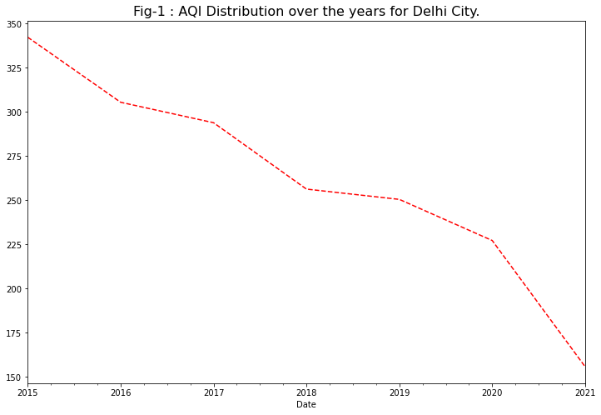Fig-1 we can see that there is drastic improvement in Air Quality of Delhi from year 2015 to 2020. So, Question’s are

1. Does Covid-19 have any Impact on air quality in Delhi?
2. Does National air quality standards are been followed?
3. Other changes pandemic has on Environment?

**Summary**

[**National Air Quality Standards**](https://www.drishtiias.com/daily-news-analysis/new-who-global-air-quality-guidelines)

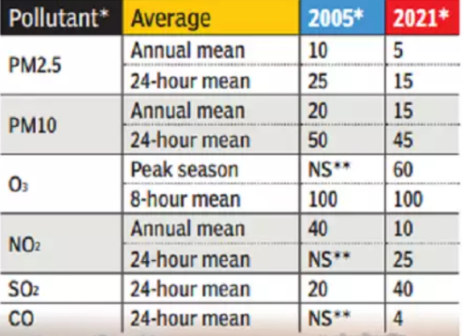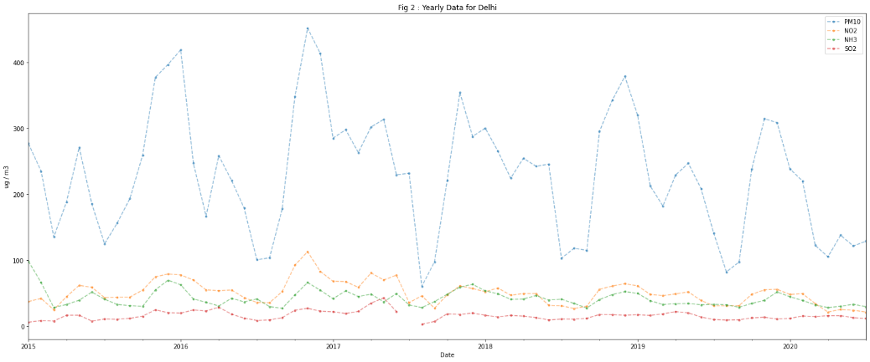

above Fig-2 we can see Delhi has not able to follow Air quality standards and comes in top 3 Air polluted State in India. According to experts this is the equivalent of smoking 45 to 50 cigarettes a day. Air pollution caused more than 16.7 lakh deaths in India in 2019 — over ten times more than the country’s Covid-19 death at that time — causing economic losses of nearly $36.8 billion (Rs 2,71,446 crore), according to a study published in The Lancet Planetary Health journal.

So, coming back to Covd-19 impact on air quality, we have plotted AQI of 2019 and 2020 which can help us to understand better.

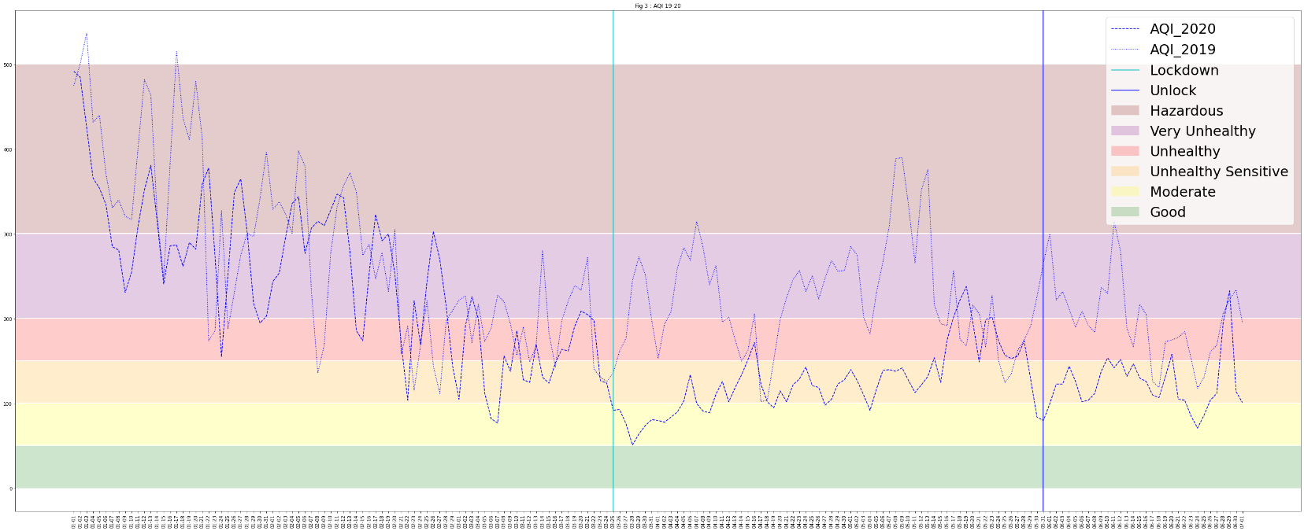

Fig 3 show drastic change in AQI in year 2019 and 2020 during lockdown.

Also, to Compare them Hypothesis test is conducted to prove whether there was a statistically significant change in air pollution during the lockdown. Although Air quality levels appear to be retreating to near pre-lockdown levels as strict lockdown measure are lifted this period has revealed some of the benefits that could be reduce noise level, clear sky etc.

* **Null Hypothesis**: There is no statistically significant difference between AQI during the lock-down period in 2020 and the same time period in 2019.
* **Test**: One-way analysis of variance and whether (ANOVA) two categorical variables are related or independent (P-Test).
* **α**: 0.05
* 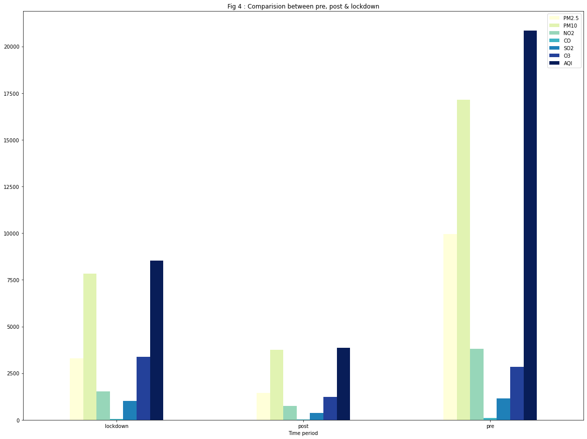**Outcome**: The null hypothesis is rejected with a p-value of 1.75 x 10-20

The hypothesis Test tells us that Delhi had Significant impact of COVID-19 on its air pollution/air quality. However, This Type of event's are extremely rare, which make them very tough to draw insight from them.

* The values of PM2.5 and PM10 have reduced by 50% compared with the pre-lockdown conditions.NO2 is also responsible for producing some harmful secondary pollutants such as ozone (O3) and nitric acid (HNO3) which can damage human life.
* A significant reduction (approx. 45% to 50%) of NO2 is noted after the worldwide lockdown. This mainly occurred due to the reduction of traffic emissions in urban cities.
* Air pollution generates many adverse effects in our social, economic, and natural environment. The major concern of air pollution is for public health and environmental challenges.

**look at pollution level through satellite imagery**

From Below Satellite imagery we can Clearly see low level of NO2 Concentration. Breathing air with a high concentration of NO2 can irritate airways in the human respiratory system. Such exposures over short periods can aggravate respiratory diseases, particularly asthma, leading to respiratory symptoms (such as coughing, wheezing or difficulty breathing), hospital admissions and visits to emergency rooms. Longer exposures to elevated concentrations of NO2 may contribute to the development of asthma and potentially increase susceptibility to respiratory infections. People with asthma, as well as children and the elderly are generally at greater risk for the health effects of NO2.

**Post Lockdown NO2** **Pre Lockdown NO2**

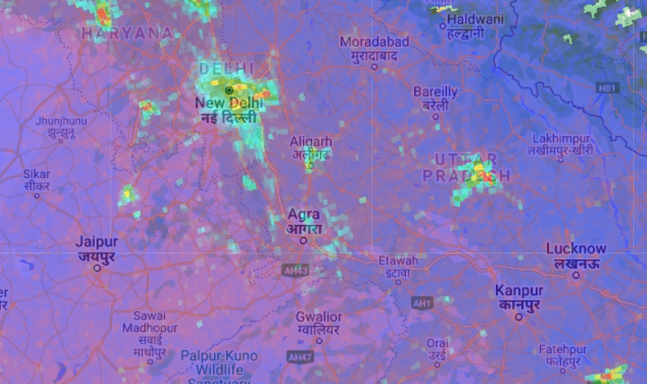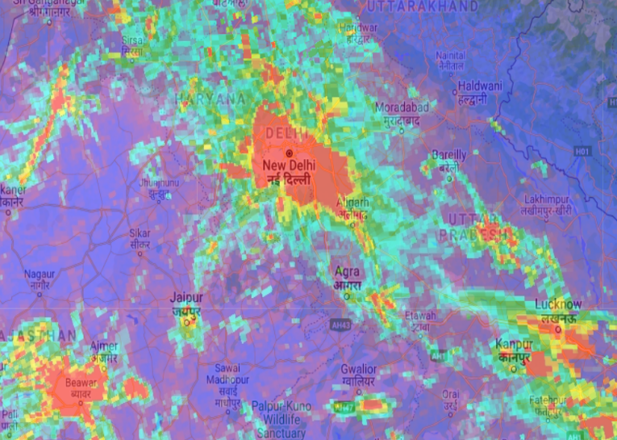

Sentinel-5 Precursor (Sentinel-5P) is an Earth observation satellite developed by ESA as part of the Copernicus Programme. The Copernicus Programme is dedicated to monitoring air pollution and Sentinel 5P Precursor is its first mission. It consists of an instrument called [Tropomi](https://showcase.earthengine.app/view/tropomi-explorer#dataset=Nitrogen%20dioxide;datatype=Offline;center=%7B%22type%22%3A%22Point%22%2C%22coordinates%22%3A%5B9.502%2C45.566%5D%7D;aoi=%7B%22type%22%3A%22MultiPoint%22%2C%22coordinates%22%3A%5B%5D%2C%22geodesic%22%3Atrue%7D;cloud=0;leftdate=2019-11-27;rightdate=2020-01-31;min=20;max=400;swipe=true;chart=yoy;zoom=4;) (TROPOspheric Monitoring Instrument) which is a spectrometer to monitor ozone, methane, formaldehyde, aerosol, carbon monoxide, NO2 and SO2 in the atmosphere. Also, with help of Google earth engine

At high concentrations, gaseous SOx can harm trees and plants by damaging foliage and decreasing growth. SO2 and other sulphur oxides can contribute to acid rain which can harm sensitive ecosystems

**Pre Lockdown SO2 Post Lockdown SO2**

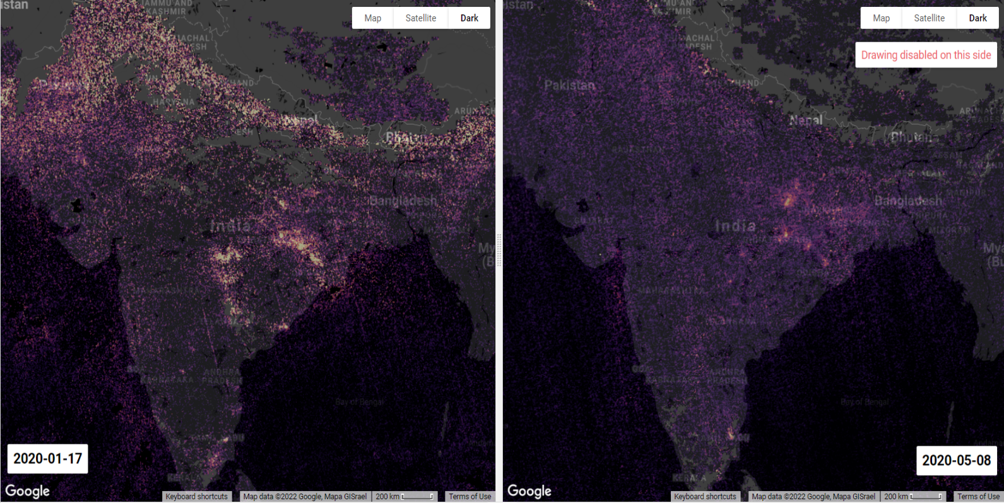

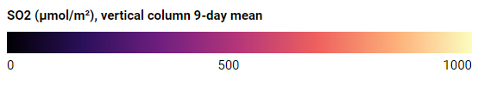

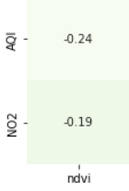Here we have also used [**Normalized Difference Vegetation Index (NDVI)**](https://link.springer.com/article/10.1007/s11356-020-12164-2)to systematically analysed the characteristics of air pollution in Delhi and used correlation coefficient to explore the relationship between NDVI and the air pollutant concentrations during the COVID-19 period. The analysis shows that AQI Areas with higher NDVI values have relatively low AQI. There is a negative correlation between NDVI and AQI, and an average increase of 0.1 in NDVI will reduce AQI by 3.75 (95% confidence interval) In the case of less human intervention, the higher the vegetation coverage, the lower the local pollutant concentration will be. Therefore, the degree of vegetation coverage would have a direct or indirect impact on air pollution.

* Clearly, the Satellite images give a stunning picture of the present and past conditions which are clearly visible in the maps above.

**Key Outcomes/Takeaways**

* Use of clean renewable energy instead of fossil fuels, ensuring equitable and affordable access for all. The pandemic has Direct impact on Energy and Greenhouse gases.
* preserving our forests and other natural sinks, as well as in expanding them.
* National Air quality standards that Delhi fails to follow. This can be Fixed through Sustainable transport systems including encouraging active travel, work from home, and implementing policies to reduce daily commuting and reducing business travel
* Invest in knowledge institutions, especially in the Global South, to strengthen their capability to produce high quality and context relevant analyses and build the requisite human resources
* Supporting NGOs in stopping large scale deforestation projects and corporations that have reforestation programs.
* measures which reduce short-lived climate pollutants such as addressing emissions from the burning or collection of municipal solid waste; these measures are often low/no-cost, and quickly achieve multiple near-term economic, public health, and social benefits

**Geospatial Data**

we have used 3 Type of Data which is provided be [google earth Engine](https://earthengine.google.com/)

1. **Sentinel-5P OFFL NO2** **Offline Nitrogen Dioxide:**

* The low level of NO2 signifies that there is less vehicle on the road & greenhouse emission
* It also gives attention to Noise pollution as anthropogenic activities are less.

1. **Tropomi**

* The TROPOMI Explorer App is an application to visualize air pollutant time series data. It facilitates quick and easy S5P TROPOMI data exploration and provide a jumping-off point for further analysis,

1. **GEE NOAA CDR AVHRR NDVI: Normalized Difference Vegetation Index, Version 5**

* The NOAA Climate Data Record (CDR) of AVHRR Normalized Difference Vegetation Index (NDVI) contains gridded daily NDVI derived from the NOAA AVHRR Surface Reflectance product. It provides a measurement of surface vegetation coverage activity, gridded at a resolution of 0.05° and computed globally over land surface.

**Improvements in terms of data/methodology**

**Data**

* Raw data which is used is collected manually from Kaggle/CPCB website, which itself has a lot of missing data Which can be either replace with help of Subject matter Expert or Use of API would have given us more update data.
* As the pandemic is rare event, we could have used more Detail data to draw insight such as Using Artificial intelligence and Deep learning on Satellite imagery, Ex: Number of cars on road, Crowded areas etc
* Use of GIS Software would be possible for Further analysis with Satellite imagery for More Better insights.